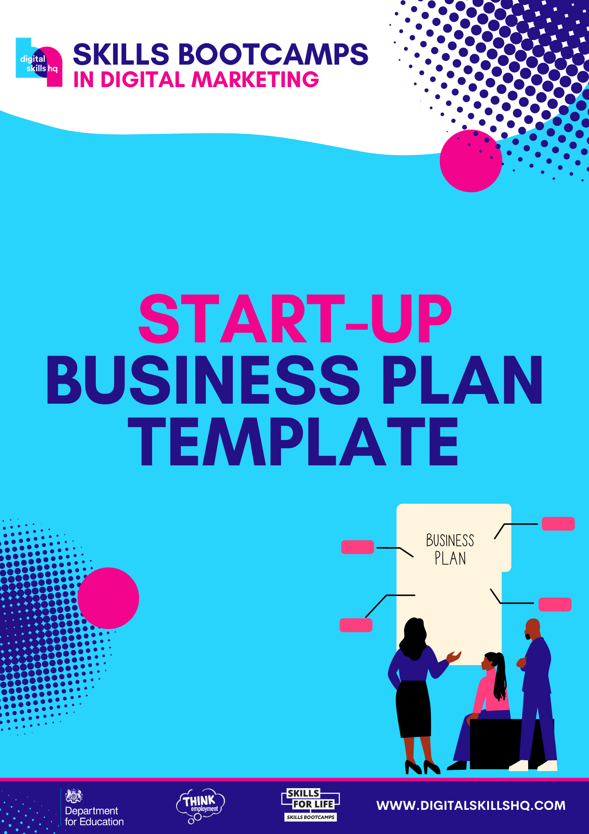

INTRODUCTION

A business plan is a planning document that outlines in words and figures your proposed business idea.

This template is just a guide to help you pull together your ideas but when you are considering starting a new business, there are many aspects to think about and putting these things down in black and white will help to highlight the areas you need to consider.

To complete the Start-Up Business Plan fully, you will need to carry out sufficient investigation into customer requirements and local competition, as well as access to supplies for your business. This procedure in itself is a good exercise in business management, a skill needed by all effective business people.

Your Business Plan is a monitoring tool for you. When you first begin your business, you will have a tremendous number of things to do and there is always the temptation, once you have started your business, to open up a drawer, drop the Business Plan in, and then forget all about it. But it is important to keep it close at hand, and to look at it monthly to see how you are progressing. Are you still following the plan? If not, how are you able to rectify the situation?

It is very easy in the early days to feel that you are doing well because you are busy and there is cash in the bank, but you need to keep an eye on the future. This is your Business Plan – you are responsible for its contents and projections. A Business Plan also needs to be a working document which is monitored and updated on a regular basis.

[Business Name]
Business Plan

Prepared By:
Date Completed:

[Insert Logo Here]

FACTOR BUSINESS PLAN CONTENTS

- Getting Started  - Business Information  - Executive Summary  - Owners Background  - Skills Analysis  - The Business  - An Introduction to The Business  - Business Objectives  - The Market  - Market Research – The Customers  - Market Research – Primary and Secondary  - Market Research – The Competitors  - Business Risks  - Business S.W.O.T Analysis  - Training Needs  - Contingency Plan | - Marketing – The 7 P’s  - Product/Service  - Price  - Place  - Promotion  - People  - Process  - Physical Evidence  - Marketing Plan  - Finance  - Start Up Costs  - Start Up Resources  - Start Up Funding Requirements  - Cash Flow Forecast

1. GETTING STARTED

1.1 BUSINESS INFORMATION

Name(s) of Owners, Partners or Directors

State whether Sole Trader, Partnership, Limited Partnership, Limited Company or Community Interest Company
Business Name (If chosen)
Business Address and Postcode
Business Telephone Number
Business Email Address
Business Website Address
Home Address and Postcode
Personal Telephone Number
Personal Email Address
(If different from above)

2. EXECUTIVE SUMMARY

Digital Skills HQ Tip
This section should give the reader an overview of your business plan, so we recommend you complete the rest of the plan first. It will summarise your business idea, where it will operate from, it’s key customers and competitors and the people involved.

Additionally, you should include details of any finance required to start the business and what volume of sales you are expecting, and profit or loss this will generate.

Oh, and don’t forget this is meant to be a summary, so try and keep it to one page if you can!

3. OWNER’S BACKGROUND

Personal Information, qualifications, career history, experience, personal profile.
Name
Career History
Personality
Hobbies and Interests
Qualifications and Previous Experience
Motivation / Why do you want to run your own business?
Training
Please attach a CV if you have one.

SKILLS ANALYSIS
(For each skill rate yourself from 1-5) 1= none 5 = high
Please complete for yourself and separately for other personnel.
Business Skills | 1 | 2 | 3 | 4 | 5
- Planning
- Market Research
- Marketing
- Financial Forecasting
- Book Keeping
Occupational Skills | 1 | 2 | 3 | 4 | 5
- Are you good at what you intend to do?
- Do you have relevant qualification?
A Support Network | 1 | 2 | 3 | 4 | 5
- Is your partner completely behind you
- Will your family help you?
- Do you have friends to call on?
- Do you have professional advisors?
Personality | 1 | 2 | 3 | 4 | 5
- Are you committed to this project?
- Are you enthusiastic?
- Are you determined to succeed?
- Can you handle failure?
- Are you logical and organised?
- Can you work with other people?
Key Abilities | 1 | 2 | 3 | 4 | 5
- Are you a good communicator?
- Are you a self-starter?
- Can you work on your own?
- Can you gather and use information?
- Can you assess risks and make decisions?
- Can you lead and direct others?
4. THE BUSINESS

4.1 AN INTRODUCTION TO THE BUSINESS

Digital Skills HQ Tip
This section should include a detailed description of what the business will do, how it will meet the needs of your prospective customers and what motivates you to want to set up in the first place. It should also include your short and medium to long term objectives, which can include financial goals, sales targets, employee numbers and personal visions of where you want to be as the business develops.

My business idea

My products/services

My reason(s) for wishing to set up this type of business

4.2 BUSINESS OBJECTIVES

The short term (1 year) objectives for my business

The medium to long term (2-5 years) objectives for my business

5. THE MARKET

5.1 MARKET RESEARCH – THE CUSTOMERS
Who is your target market?
Other Businesses (B2B)
Both
Individual Consumers (B2C)
Who are your customers? Describe your typical customer
Where are you customers based?
Why will customers want to purchase your products/services?
How will they find out about your products or services?
How often do you think they may purchase your products or services?
Is your market growing or declining and why?

5.2 MARKET RESEARCH - PRIMARY & SECONDARY

Digital Skills HQ Tip
There are two types of market research:
- Primary – This is conducted through talking to potential customers, suppliers and any other relevant parties via questionnaires, interviews and focus groups etc. This will provide you with data that is specific to your business.
- Secondary – This research is conducted through researching the market you are entering and finding out basic facts which will help your business. This can be found through government statistics (ons.gov.uk), reliable sources on the internet, published articles, books etc.
This section should outline what type of research you have carried out and the key findings from this research.

Primary Research
Type of Survey
Key Findings
Secondary Research
Type of Survey
Key Findings

Additional Information

5.3 MARKET RESEARCH – THE COMPETITORS

Who are your competitors?  (Name, Location, Business Size) | How do they promote their business? | How will they react to your business venture? | In terms of quality, price, promotion, distribution, strengths and weaknesses
 |  |  | Advantages you have over them | Advantages they have over you

6. BUSINESS RISKS

6.1 BUSINESS ‘S.W.O.T’ ANALYSIS

Digital Skills HQ Tip
A ‘S.W.O.T’ Analysis will enable you to understand all things good and bad that may affect your business. Once you have identified these key areas and listed them below, you can focus on how to overcome them or use them to your advantage.
If you identify you need more training in a particular area, you should write this in section 6.2 along with the details of the training course.

Strengths | Weaknesses
Opportunities | Threats

6.2 TRAINING NEEDS
Training courses needed to be completed

6.3 CONTINGENCY PLANS
Contingency plan if unable to work through illness / injury, etc

7. MARKETING – THE 7 P’s

Digital Skills HQ Tips
This section breaks down the 7P’s (as seen below), something which helps with planning, developing, and executing effective marketing strategies. By using an informed and streamlined strategy, you will better able to gain and retain your customers and ensure that you meet and achieve your goals. It is therefore useful to fill these sections in with as much detail as possible.

PRODUCT / SERVICE
Digital Skills HQ Tip: This defines what your products/services are, including the unique selling points (USP) which will help sell your products/services.

PRICE
Digital Skills HQ Tip: This is the price the products/services are to be sold at to your target audience. When calculating this, consider all costs involved including production, promotion, and delivery, plus the margin you require to meet your other costs and your profit.

PLACE
Digital Skills HQ Tip: Place is the distribution point of a product and where customers expect to find it. Therefore, describe your selling platforms – such as a website, your shop, Amazon, eBay, third party retailers, etc.

PROMOTION
Digital Skills HQ Tip: Promotion refers to the marketing techniques to be used: some promotional tools include social media, website, paid internet ads, personal Selling, email marketing, and PR. Other aspects of promotion can include samples, free gifts, incentives and competitions.

PEOPLE
Digital Skills HQ Tip: Having the right people who work for your business is essential, therefore it is important to work out how many employees may be needed and their level of expertise for the business to be successful.

PROCESS
Digital Skills HQ Tip: The processes involved in a product’s delivery include website user experience, delivery time, delivery methods and aftercare. Other considerations may include your environmental impact and how your processes affect buying decisions for your customers. It is important to have strict processes in place and back-up plans that take account of their expectations.

PHYSICAL EVIDENCE
Digital Skills HQ Tip: Your marketing mix must take into consideration all the things your customer sees, hears (sometimes even smells) – in relation to your products or services. All of this must reflect your brand values and can include thank you cards, confirmation emails, product packaging, signage, and brochures. It could also include the ways your products are displayed or the way you present them across your digital assets, such as your website and social media. Focusing on an appealing and consistent overall look and feel will create a positive experience for the customer.

Marketing Method | How will you implement this method? | When | Where | Cost | Return

Social Media

Website

Internet Ads

Email marketing

Brochures / Leaflet Marketing

Sponsorships / Events

Trade Shows / Exhibitions

Loyalty Programmes

Media Coverage (PR)
8. MARKETING PLAN

9. FINANCE

START UP COSTS

Property (If Relevant)
 | Lease Deposit | £
 | Rent in Advance | £
 | Legal Fees | £
 | Planning & Surveyors Fees | £
 | Property Insurance | £
 | Installation of Telephone / Broadband | £
 | Installation of Gas, Electric and Water | £
 | Refurbishment / Alterations to Property | £
 | Transport (If Relevant)
 | Lease / Rental | £
 | Motor Insurance | £
 | Road Tax | £
Other Costs
Fire and Safety Equipment |  | £
Signwriting, Notice Boards |  | £
z |  | £
PPE (Personal Protection Equipment) |  | £
Paid Advertising |  | £
Website and Digital Tools (Including Accounting Software) |  | £
Other Professional Fees |  | £
Insurance |  | £
Miscellaneous |  | £
Total requirement (A) |  | £
9.2 START-UP RESOURCES
Digital Skills HQ Tip
Capital Equipment generally has a life span of over a year and are physical items acquired for productive activity.

Capital Equipment Requirements | Already Owned | Still Required
 | £ | £
 | £ | £
 | £ | £
 | £ | £
Equipment/fixtures (include installation costs) | Already Owned | Still Required
 | £ | £
 | £ | £
 | £ | £
 | £ | £
Materials | Already Owned | Still Required
 | £ | £
 | £ | £
 | £ | £
 | £ | £
Stock | Already Owned | Still Required
 | £ | £
 | £ | £
 | £ | £
 | £ | £
Total Already Owned (B) | £
Total Required (C) |  | £

9.3 START-UP FUNDING REQUIREMENTS

Digital Skills HQ Tip
To calculate your Pre-Start Requirements, add the Start Up Costs (A) (page 19) to Physical Resources Owned (B) (page 20) and Physical Resources Required (C) (page 20).
Working capital is the additional amount required to operate your business on a day-to-day basis.

Costs and Resources
Start Up Costs (A) £
Physical Resources Owned (B) £
Physical Resources Required (C) £
Working Capital (if required) £

Total Pre-Start Requirements £

Less: £
Physical Resources Owned (B) £
Cash Resources Required £

9.4 CASH FLOW FORECAST

Digital Skills HQ Tip
The most essential part of your business plan is a cash flow forecast, which tracks your cash coming in and going out, on a monthly basis. Understanding and predicting cash flow is the key to keeping track of your purse strings and ensuring you don’t overspend.
Start-Ups often have a large number of costs in their setup period. This large negative cash flow will need to be plugged with funding until sales have had a chance to grow – known as working capital. A sales forecast can help you develop a pattern of sales income, in support of the figures put into your cash flow forecast.
In addition, a personal survival budget is a useful tool to quantify your household expenditure and to gauge the level of drawings you will need from your business after taking into account the potential loss of existing wages/benefits.
Templates for these three spreadsheets can be found on our website.

Please complete these templates and set out details of your assumptions below, e.g., any start-up or seasonal adjustments.

